**STUDENTS GUIDELINES**

There is 1Hr 40 Minutes allocated to a laboratory session in Computer Organization. It is a necessary part of the course at which attendance is compulsory.

Here are some guidelines to help you perform the experiments and to submit the reports:

1. Read all instructions carefully and carry them all out.
2. Ask a demonstrator if you are unsure of anything.
3. Record actual results (comment on them if they are unexpected!)
4. Write up full and suitable conclusions for each experiment.
5. If you have any doubt about the safety of any procedure, contact the demonstrator beforehand.
6. THINK about what you are doing!

**Experiment No: 1**

**AIM:** Introduction to Digital Laboratory Equipments & IC‟s.

**The Breadboard** The breadboard consists of two terminal strips and two bus strips (often broken in the centre). Each bus strip has two rows of contacts. Each of the two rows of contacts are a node. That is, each contact along a row on a bus strip is connected together (inside the breadboard). Bus strips are used primarily for power supply connections, but are also used for any node requiring a large number of connections. Each terminal strip has 60 rows and 5 columns of contacts on each side of the centre gap. Each row of 5 contacts is a node. You will build your circuits on the terminal strips by inserting the leads of circuit components into the contact receptacles and making connections with 22-26 gauge wire. There are wire cutter/strippers and a spool of wire in the lab. It is a good practice to wire +5V and 0V power supply connections to separate bus strips.

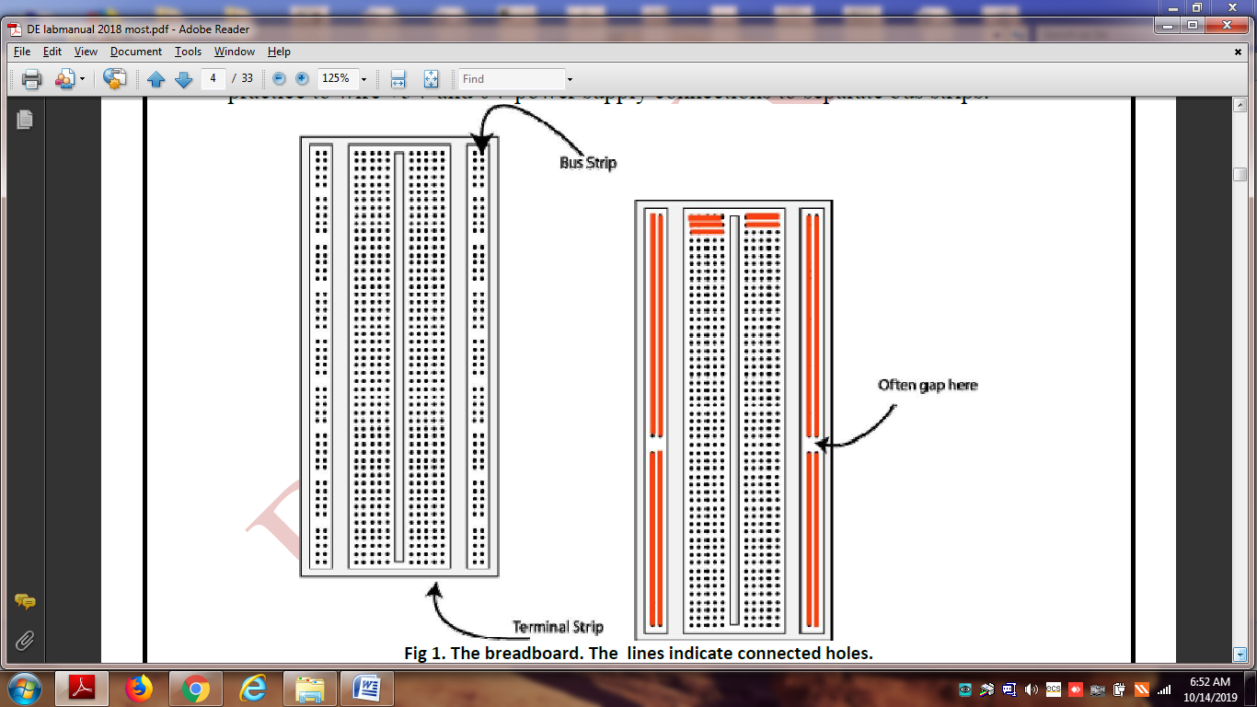

The 5V supply **MUST NOT BE EXCEEDED** since this will damage the ICs (Integrated circuits) used during the experiments. Incorrect connection of power to the ICs could result in them exploding or becoming very hot - with the **possible serious injury occurring to the people working on the experiment! Ensure that the power supply polarity and all components and connections are correct before switching on power.**

**Building the Circuit:** Throughout these experiments we will use TTL chips to build circuits. The steps for wiring a circuit should be completed in the order described below:

1. Turn the power (Trainer Kit) off before you build anything!
2. Make sure the power is off before you build anything!
3. Connect the +5V and ground (GND) leads of the power supply to the power and ground bus strips on your breadboard.
4. Plug the chips you will be using into the breadboard. Point all the chips in the same direction with pin 1 at the upper-left corner. (Pin 1 is often identified by a dot or a notch next to it on the chip package)
5. Connect +5V and GND pins of each chip to the power and ground bus strips on the breadboard.
6. Select a connection on your schematic and place a piece of hook-up wire between corresponding pins of the chips on your breadboard. It is better to make the short connections before the longer ones. Mark each connection on your schematic as you go, so as not to try to make the same connection again at a later stage.
7. Get one of your group members to check the connections, **before you turn the power on**.
8. If an error is made and is not spotted before you turn the power on. Turn the power off immediately before you begin to rewire the circuit.
9. At the end of the laboratory session, collect you hook-up wires, chips and all equipment and return them to the demonstrator.
10. Tidy the area that you were working in and leave it in the same condition as it was before you started.

**Common Causes of Problems:**

1. Not connecting the ground and/or power pins for all chips.
2. Not turning on the power supply before checking the operation of the circuit.
3. Leaving out wires.
4. Plugging wires into the wrong holes.
5. Driving a single gate input with the outputs of two or more gates
6. Modifying the circuit with the power on.

**Useful IC Pin details:**

|  |  |
| --- | --- |
| **IC NUMBER** | **Description of IC** |
| 7400 | Quad2inputNANDGATE |
| 7401 | Quad2inputNANDGate(opencollector) |
| 7402 | Quad 2 input NOR Gate |
| 7403 | Quad2inputNORGates(opencollector) |
| 7404 | Hex Inverts |
| 7421 | Dual 4 input AND Gates |
| 7430 | 8 input NAND Gate |
| 7432 | Quad 2 input OR Gates |
| 7486 | Quad 2 input EX-OR Gate |
| 74107 | Dual j-k Flip Flop |
| 74109 | Dual j-k Flip Flop |
| 74174 | Hex D Flip Flop |
| 74173 | Quad D Flip Flop |
| 7473 | Dual j-k Flip Flop |
| 7474 | Dual D Flip Flop |
| 7475 | Quad Bi-stable latch |

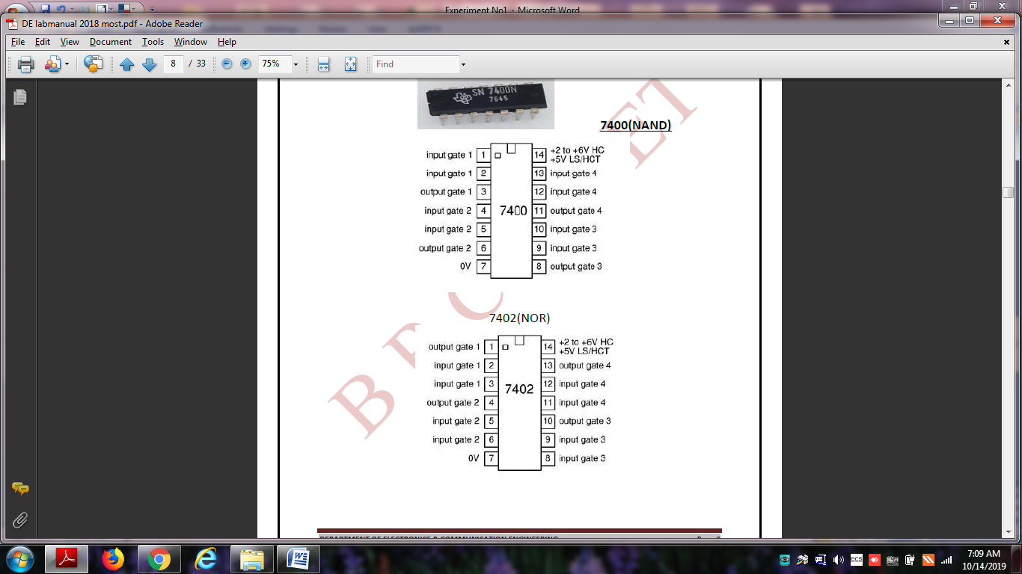 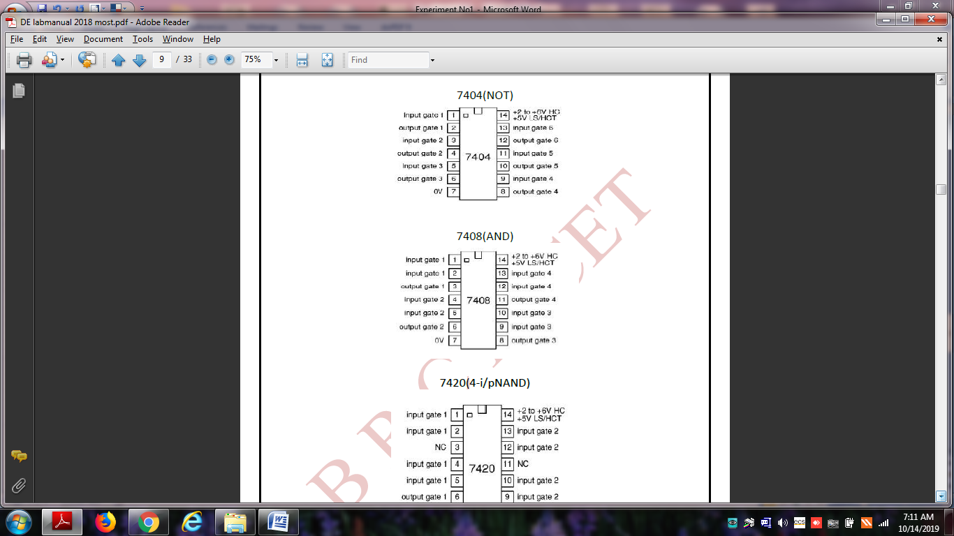 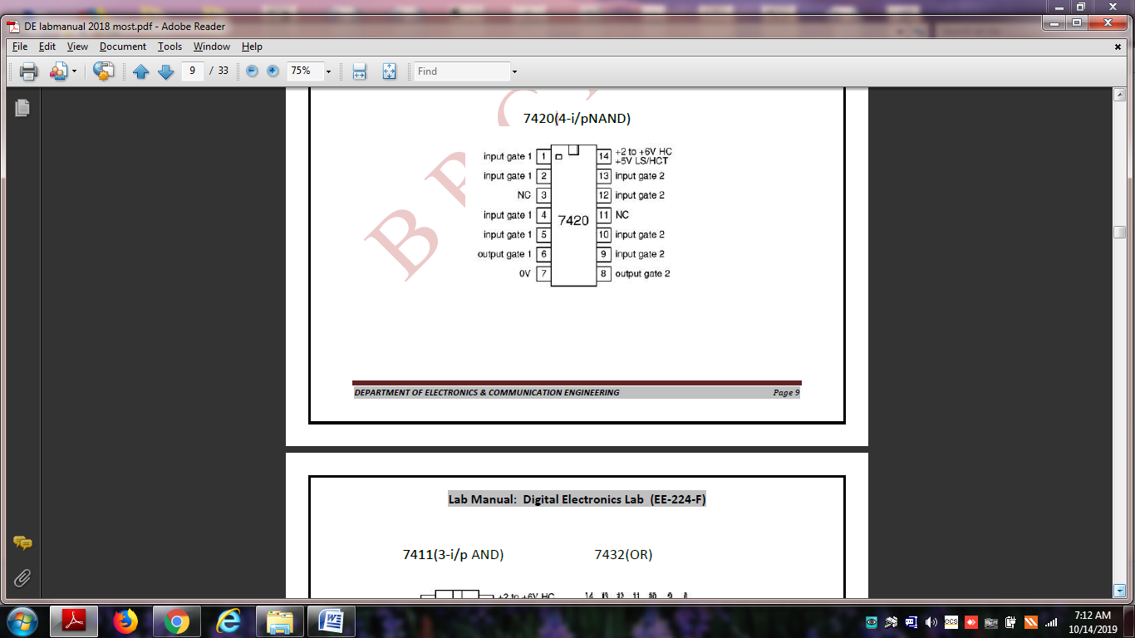

**Experiment No: 2**

**AIM: -** To study basic gates AND and verify their truth tables.

**APPARATUS: -** LED, IC- 7408, Wires, +5 volts DC supply, Bread Board etc.

**THEORY:**- In AND gate circuit it has n input and only one output. Digital signals are applied in input terminal. In the AND gate operation is „t‟ if and only if all the input are „1‟ otherwise zero. Mathematically: The output Q is true if input A and input B are both true: **Q = A AND B** An AND gate can have two or more inputs, its output is true if all inputs are true.

Procedure:-

1. Place the IC on IC Trainer Kit.
2. Connect Vcc and ground to respective pins 14 and 7 of IC trainer kit.
3. Connect the input to the input switches provided in the IC Trainer Kit.
4. Connect the outputs to the switches of O/P LEDs.
5. Apply various combinations of inputs according to the truth table and observe condition of LEDs.
6. Disconnect output from the LEDs and note down the corresponding signal for various combinations of inputs.

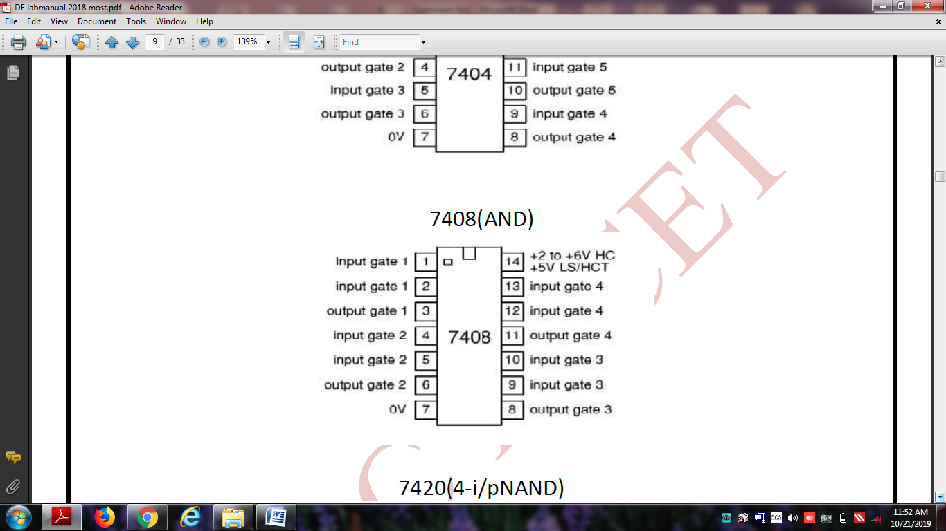

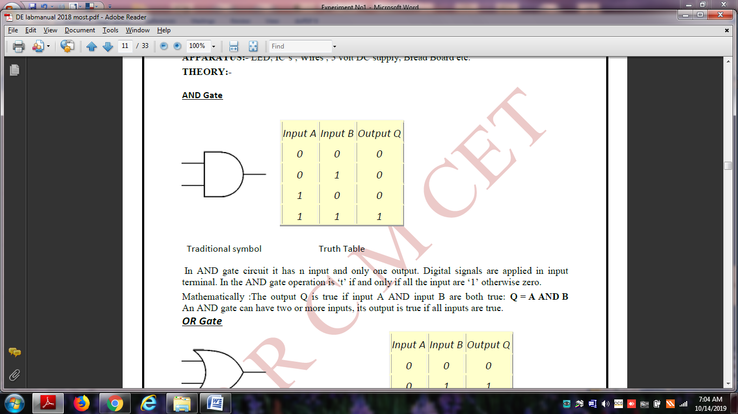

**RESULT: -** Corresponding truth tables of logic gates are verified.

**PRECAUTIONS:-**

1. Supply should not exceed 5v.

2. Connections should be tight and easy to inspect.

3. Use L.E.D. with proper sign convention and check it before connecting in circuit.

**Experiment No: 3**

**AIM: -** To study basic gates OR and verify their truth tables.

**APPARATUS: -** LED, IC- 7432, Wires, +5 volt DC supply, Bread Board etc.

**THEORY:** - The OR gate gets its name from the fact that it behaves after the fashion of the logical inclusive "or." The output is "true" if either or both of the inputs are "true." If both inputs are "false," then the output is "false." In other words, for the output to be 1, at least input one OR two must be 1.

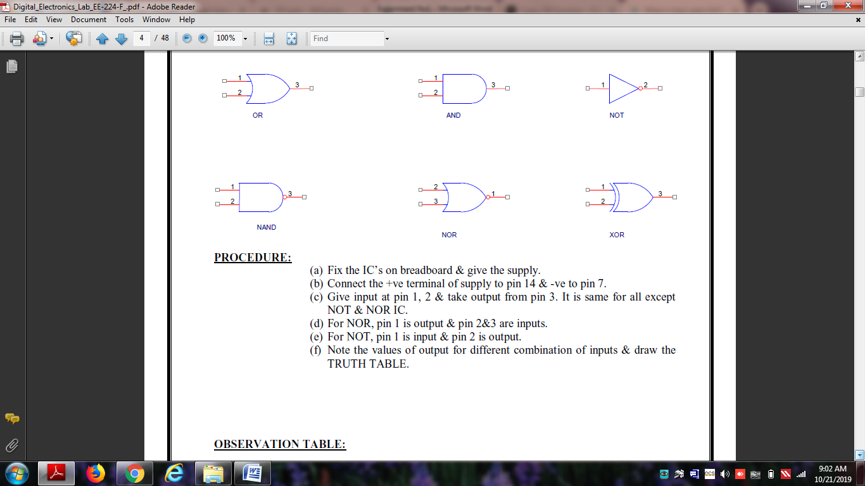

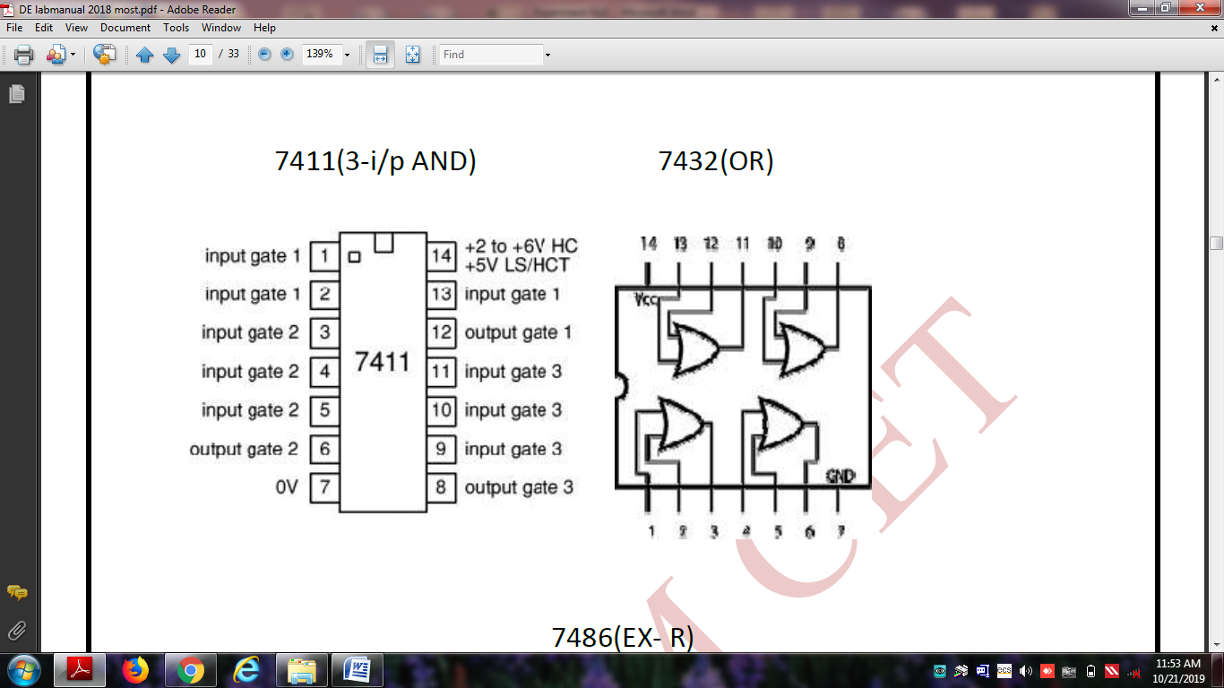

OR GATE IC-7432

**Procedure:-**

1. Place the IC on IC Trainer Kit.
2. Connect Vcc and ground to respective pins 14 and 7 of IC trainer kit.
3. Connect the input to the input switches provided in the IC Trainer Kit.
4. Connect the outputs to the switches of O/P LEDs.
5. Apply various combinations of inputs according to the truth table and observe condition of LEDs.
6. Disconnect output from the LEDs and note down the corresponding signal for various combinations of inputs.

**RESULT: -** Corresponding truth tables of logic gates are verified.

**PRECAUTIONS:-**

1. Supply should not exceed +5v.

2. Connections should be tight and easy to inspect.

3. Use L.E.D. with proper sign convention and check it before connecting in circuit.

**Experiment No: 4**

**AIM: -** To study basic gates NOT and verify their truth tables.

**APPARATUS: -** LED, IC- 7404, Wires, +5 volt DC supply, Bread Board etc.

**THEORY: -** A logical inverter, sometimes called a NOT gate to differentiate it from other types of electronic inverter devices, has only one input. It reverses the logic state. If the input is 1, then the output is 0. If the input is 0, then the output is 1.

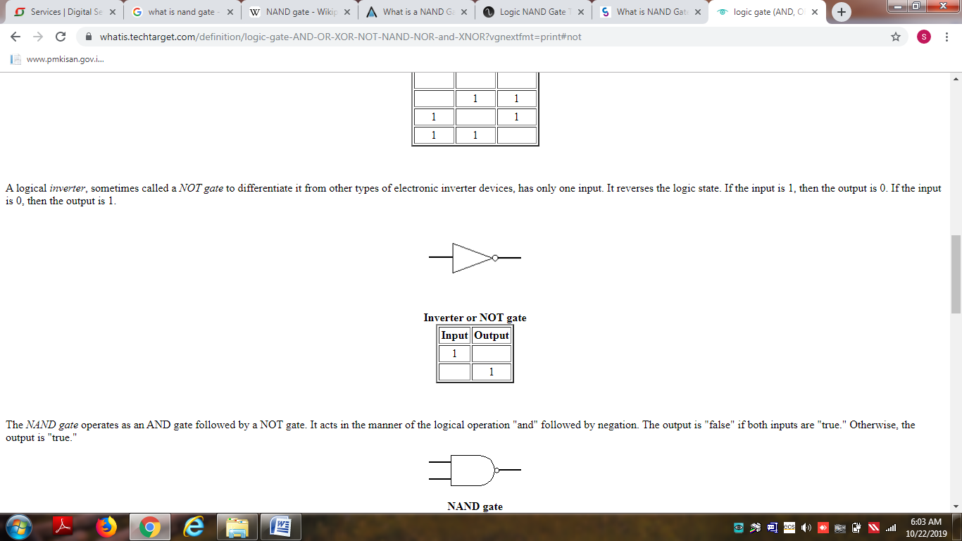

**NOT Gate**

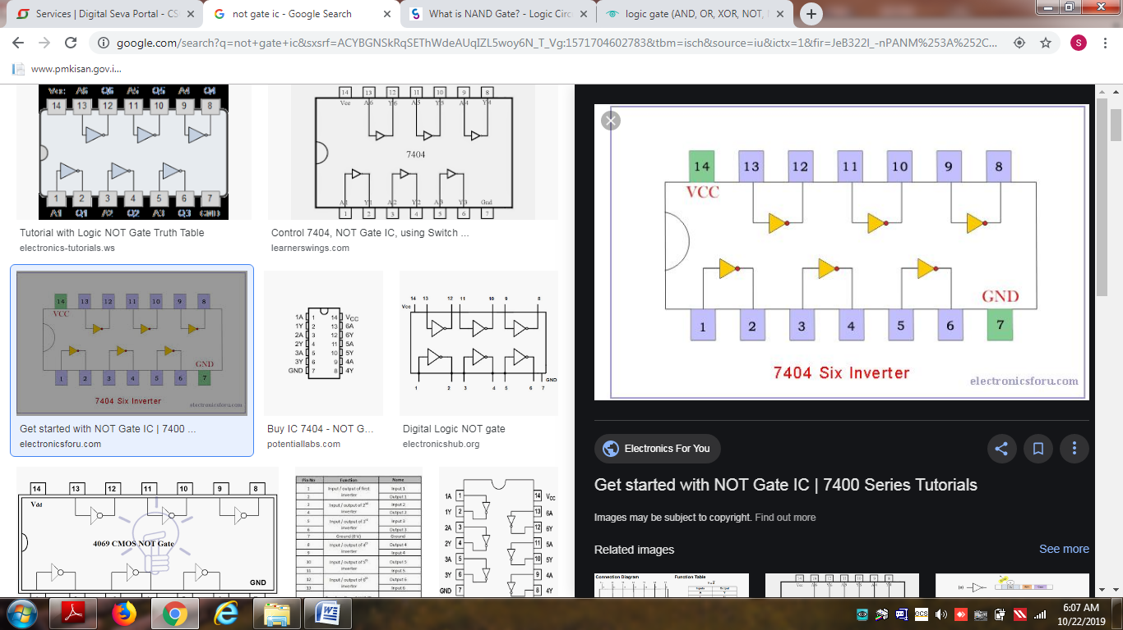

**NOT GATE IC- 7404**

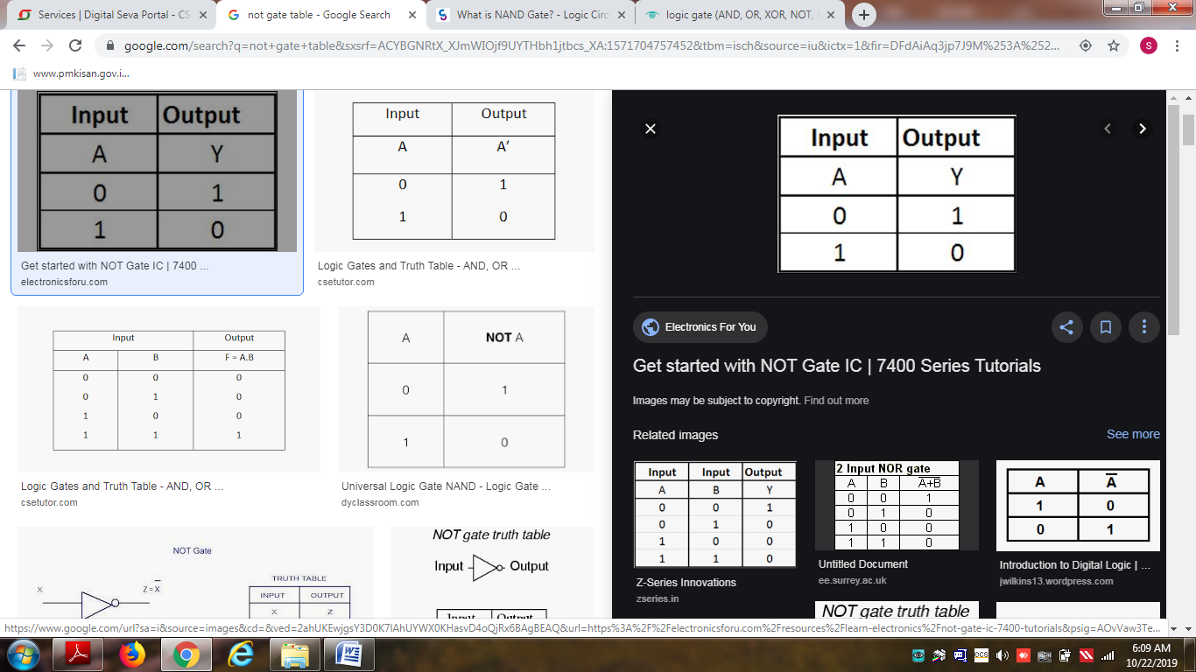

**NOT gate table**

**Procedure:-**

1. Place the IC on IC Trainer Kit.
2. Connect Vcc and ground to respective pins 14 and 7 of IC trainer kit.
3. Connect the input to the input switches provided in the IC Trainer Kit.
4. Connect the outputs to the switches of O/P LEDs.
5. Apply various combinations of inputs according to the truth table and observe condition of LEDs.
6. Disconnect output from the LEDs and note down the corresponding signal for various combinations of inputs.

**RESULT: -** Corresponding truth tables of logic gates are verified.

**PRECAUTIONS:-**

1. Supply should not exceed +5v.

2. Connections should be tight and easy to inspect.

3. Use L.E.D. with proper sign convention and check it before connecting in circuit.

**Experiment No: 5**

**AIM: -** To study basic gates NAND and verify their truth tables.

**APPARATUS: -** LED, IC- 7400, Wires, +5 volt DC supply, Bread Board etc.

**THEORY: -** The NAND gate operates as an AND gate followed by a NOT gate. It acts in the manner of the logical operation "and" followed by negation. The output is "false" if both inputs are "true." Otherwise, the output is "true."

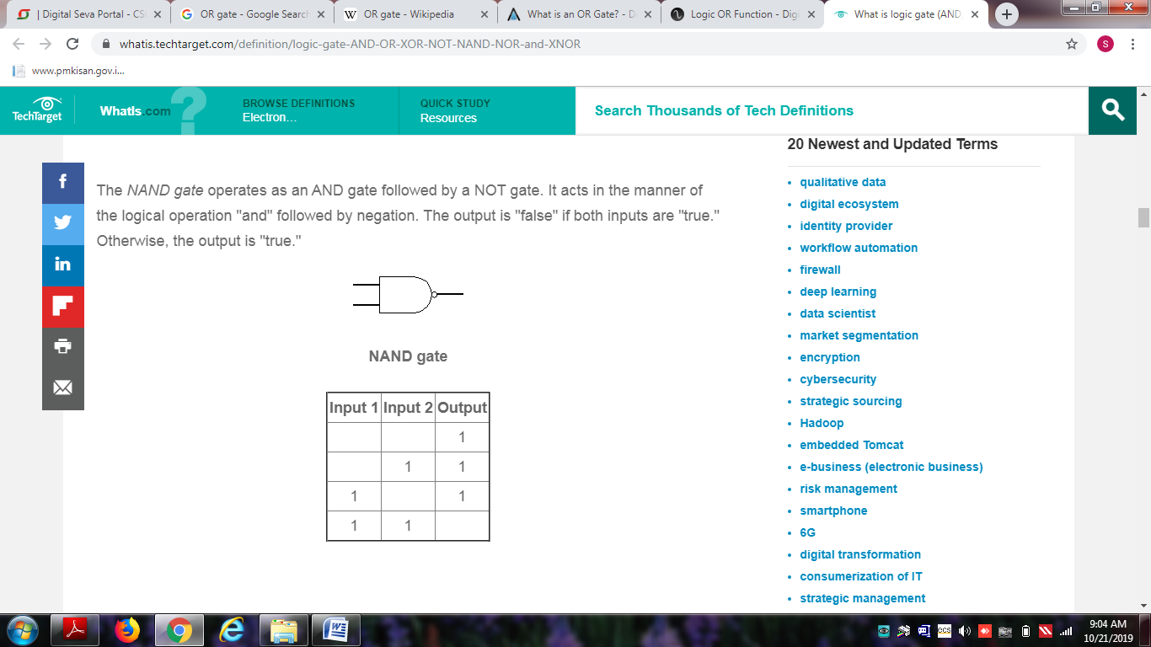



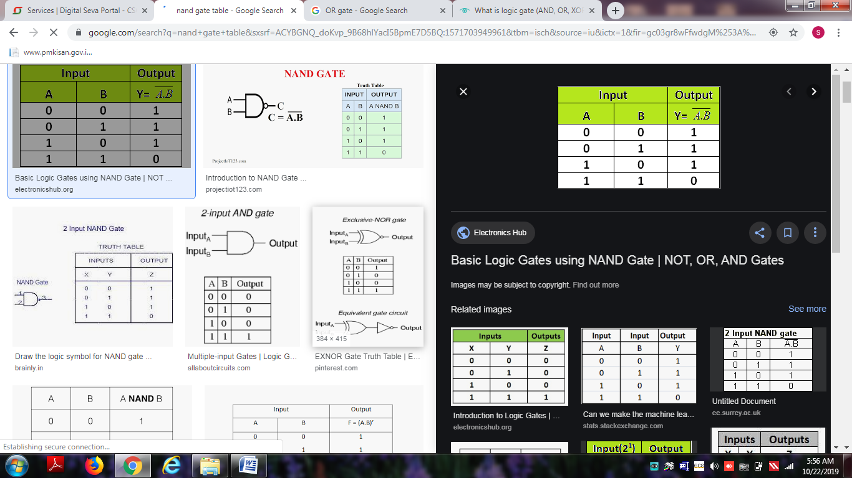

**Procedure:-**

1. Place the IC on IC Trainer Kit.
2. Connect Vcc and ground to respective pins 14 and 7 of IC trainer kit.
3. Connect the input to the input switches provided in the IC Trainer Kit.
4. Connect the outputs to the switches of O/P LEDs.
5. Apply various combinations of inputs according to the truth table and observe condition of LEDs.
6. Disconnect output from the LEDs and note down the corresponding signal for various combinations of inputs.

**RESULT: -** Corresponding truth tables of logic gates are verified.

**PRECAUTIONS:-**

1. Supply should not exceed +5v.

2. Connections should be tight and easy to inspect.

3. Use L.E.D. with proper sign convention and check it before connecting in circuit.

**Experiment No: 6**

**AIM: -** To study basic gates NOR and verify their truth tables.

**APPARATUS: -** LED, IC- 7402, Wires, +5 volt DC supply, Bread Board etc.

**THEORY: -**

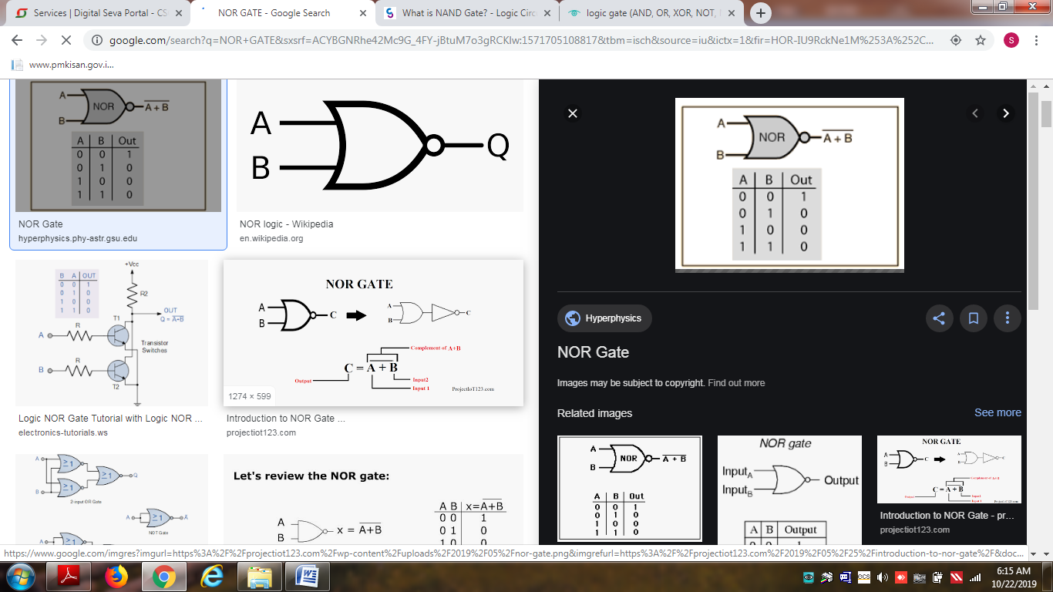

NOR GATE

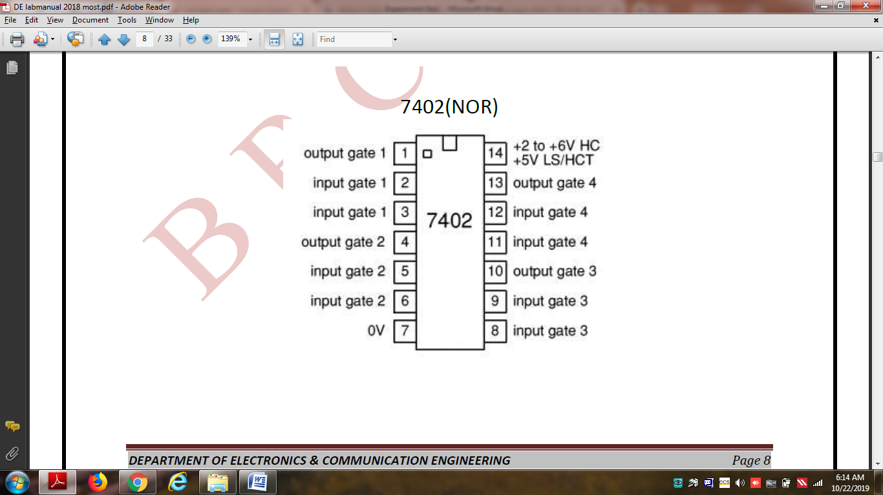

NOR GATE IC-7402

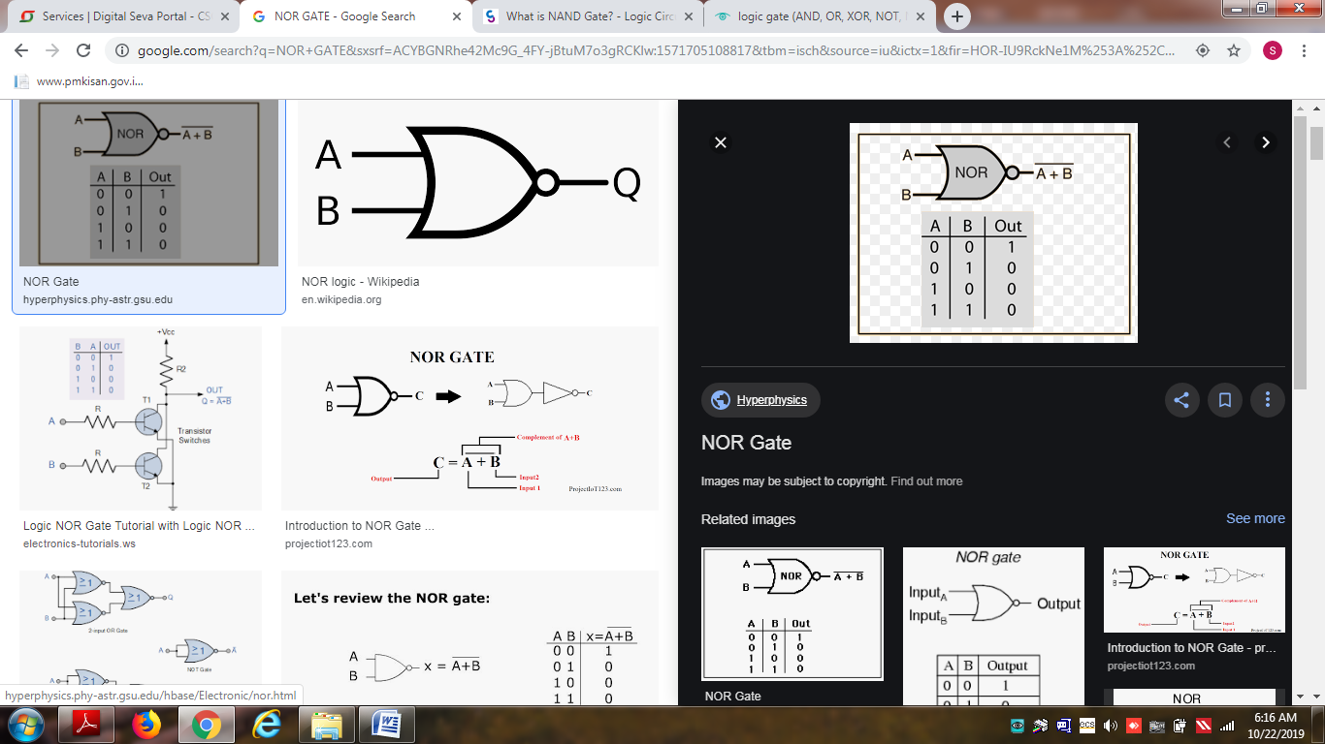

NOR GATE TABLE

**Procedure:-**

1. Place the IC on IC Trainer Kit.
2. Connect Vcc and ground to respective pins 14 and 7 of IC trainer kit.
3. Connect the input to the input switches provided in the IC Trainer Kit.
4. Connect the outputs to the switches of O/P LEDs.
5. Apply various combinations of inputs according to the truth table and observe condition of LEDs.
6. Disconnect output from the LEDs and note down the corresponding signal for various combinations of inputs.

**RESULT: -** Corresponding truth tables of logic gates are verified.

**PRECAUTIONS:-**

1. Supply should not exceed +5v.

2. Connections should be tight and easy to inspect.

3. Use L.E.D. with proper sign convention and check it before connecting in circuit.

**Experiment No: 7**

**AIM:-**To study about full adder & verify its truth table.

**APPARATUS:-**IC-(7486, 7408, 7432), Connecting wires, LED, Bread board, Cutter, 5v supply.

**THEORY:-**

A half adder has only two inputs and there is no provision to add a carry coming from the lower order bits when multibit addition is performed. For this purpose, a third input terminal is added and this circuit is used to add An, Bn and Cn-1 where An and Bn are the nth order bits of the numbers A and B respectively and Cn-1 is the carry generated from the addition of (n-1)th order bits. This circuit is referred to as FULL-ADDER.

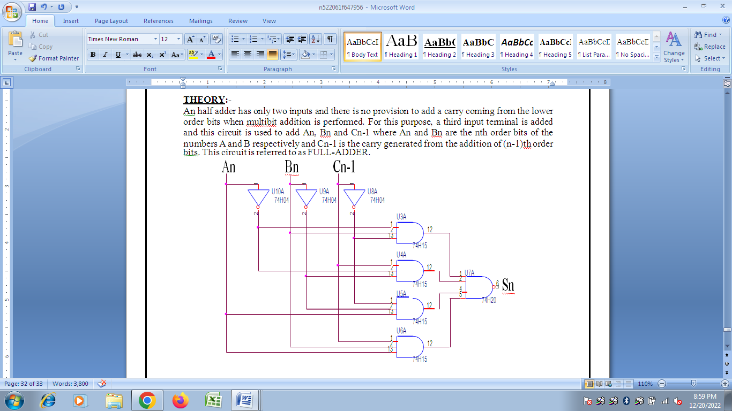

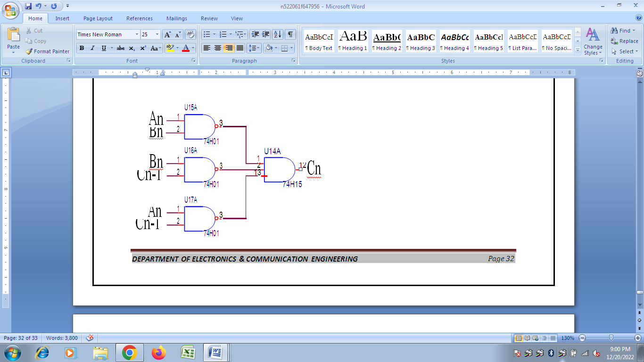

**TRUTH TABLE:-**

|  |  |  |  |  |
| --- | --- | --- | --- | --- |
| ***INPUTS*** | | | ***OUTPUTS*** | |
| *An* | *Bn* | *Cn-1* | *SUM* | *CARRY* |
| *0* | *0* | *0* | *0* | *0* |
| *0* | *0* | *1* | *1* | *0* |
| *0* | *1* | *0* | *1* | *0* |
| *0* | *1* | *1* | *0* | *1* |
| *1* | *0* | *0* | *1* | *0* |
| *1* | *0* | *1* | *0* | *1* |
| *1* | *1* | *0* | *0* | *1* |
| *1* | *1* | *1* | *1* | *1* |

**PROCEDURE:-**

1. Write the truth table for variables An,Bn and Cn-1.
2. Truth table was solved with the help of K-map.
3. Circuit was connected and the outputs of sum and carry was got separately.
4. Connect the pin no.14 to 5v supply of all IC‟s used in circuit. 5.Pin no. 7 will be grounded of all IC‟s.

**RESULT: -** The truth table of full adder is verified.

**PRECAUTIONS:-**

1. Supply should not exceed 5v.

2. Connections should be tight and easy to inspect.

3. Use L.E.D. with proper sign convention and check it before conneting in circuit.

**Experiment No: 8**

**AIM:** To design and implement multiplexer.

**APPARATUS REQUIRED:**

|  |  |  |  |  |
| --- | --- | --- | --- | --- |
| Sl.No. | COMPONENT |  | SPECIFICATION | QTY. |
| 1. | 3 I/P AND GATE | IC 7411 |  | 2 |
| 2. | OR GATE | IC 7432 | 1 |  |
| 3. | NOT GATE | IC 7404 |  | 1 |
| 4. | IC TRAINER KIT - |  | 1 |  |
| 5. | PATCH CORDS - |  |  |  |

**THEORY:**

**MULTIPLEXER:**

Multiplexer means transmitting a large number of information units over a smaller number of channels or lines. A digital multiplexer is a combinational circuit that selects binary information from one of many input lines and directs it to a single output line. The selection of a particular input line is controlled by a set of selection lines. Normally there are 2n input line and n selection lines whose bit combination determine which input is selected.

**BLOCK DIAGRAM FOR 4:1 MULTIPLEXER**

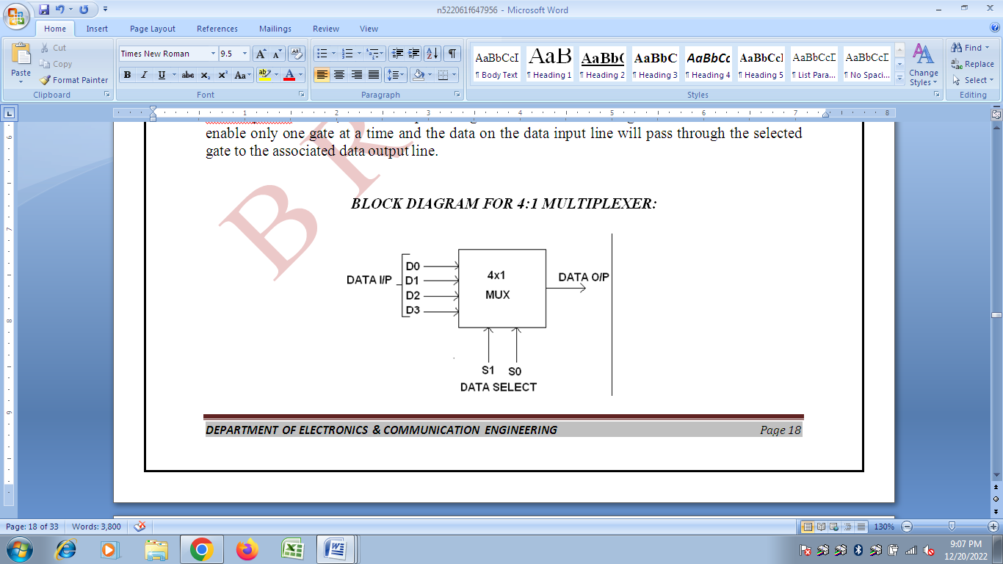

**FUNCTION TABLE:**

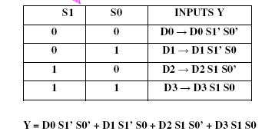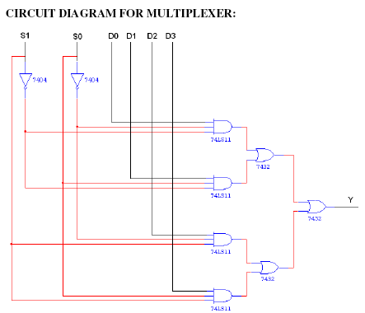

**TRUTH TABLE:**

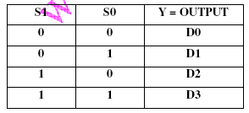

**IC Number-75150**

**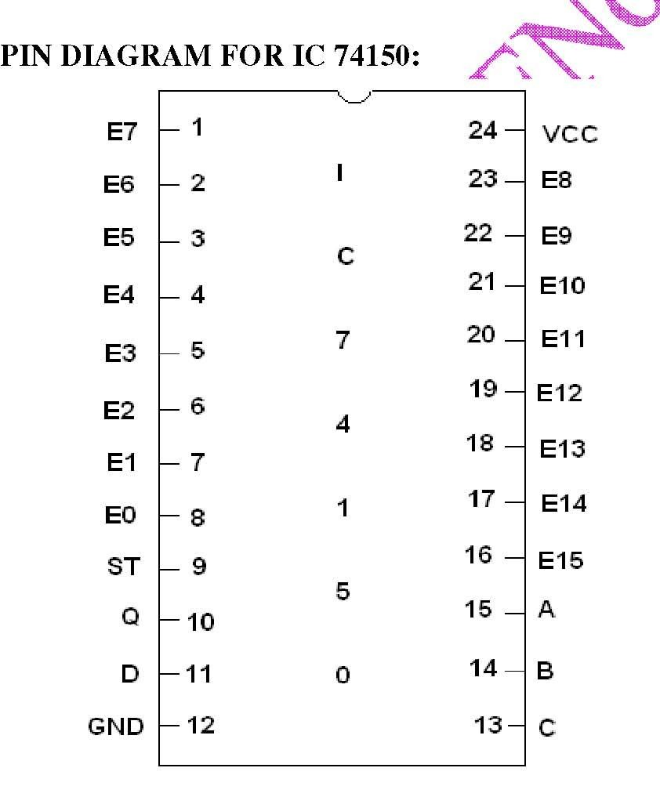  
PIN DIAGRAM FOR IC 74154:**

**PROCEDURE:**

(i) Connections are given as per circuit diagram.

(ii) Logical inputs are given as per circuit diagram.

**RESULT:**

Thus the design and implementation of Multiplexer using logic gates and study of IC 74150 were done.